Veteran’s History Project Overview
“A thing may happen and be a total lie; another thing may not happen and be truer than the truth.”
-Tim O’Brien, “The Things They Carried”
“Everyone falsifies history even if it is only his own personal history. Sometimes the falsification is deliberate, sometimes unconscious; put always the past is altered to suit the needs of the present. The best we can say of any account is not that it is the real truth at last, but that this is how the story appears now.”
-Joseph Freeman
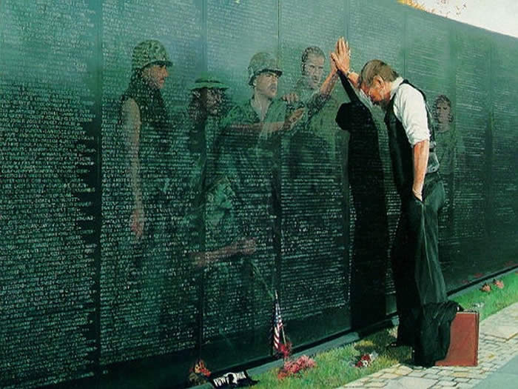

Context and Relevance
Many of us have veterans from the Vietnam War in our immediate families. Fathers, uncles, grandfathers, cousins…there are few families who remained completely untouched by this conflict. We have been surrounded by iconic images from this war: the Vietnam Memorial, children running from napalm attacks, Vietnamese climbing the walls of Saigon. Despite the pervasiveness of this conflict in our culture, it sometimes seems difficult to find a discussion of Vietnam that tackles the conflict in all its complexity, taking into account the historical background and forces that influenced the shape of the conflict, and the stories of the veterans and how their lives were forever shaped by their participation. During this project, you will attempt to capture historical narratives in two different ways, and will continue to track and try to capture the elusive truth of this war. Through this project, you will discover the difficulty of telling a true historical narrative, and the power of capturing a single story.

Project Overview
For this project, you will be crafting two historical narratives of history—one from a broad historical perspective, and one that focuses on a single veteran.
Narrative One: Gulf of Tonkin History
For this first narrative, you will be exploring how we can find the truth of historical events when there are many conflicting sources. After learning about the larger context of Vietnam and the Cold War, you will use historical thinking skills to dig your way through a confusing mass of documents about the Gulf of Tonkin incident, and will ultimately write a history of this event that is supported by your analysis of these primary sources.

Narrative Two: Library of Congress Veteran Interview
In this project, you will be working in groups of 2-3 to conduct a videotaped interview of a veteran to submit to the Library of Congress’ Veterans History Project. Through these videos, you will have a chance to make history by contributing to our nation’s historical archives, and to gain a much closer view of the Vietnam War by seeing it through the eyes of a veteran. In addition to the video, your group will be responsible for all related documentation that is necessary for this project. This project will be exhibited online on the Library of Congress website. You will also be mailing a finished copy of all documentation and the video to the family of the veteran for their own personal family history.

Essential Questions
- How can we know the truth of history when there are conflicting sources?
- What stories do veterans of the Vietnam War have to tell?
- What truths of war can be found in historical documents? In veteran’s stories?

Objectives
By the end of this project, you should have the following skills and knowledge well in hand.
Skills:
- Use the historical thinking skills of sourcing, contextualization, close reading, background knowledge, reading the silences, and corroboration to determine the reliability of conflicting primary source documents.
- Use various discussion strategies to verbally communicate ideas that are grounded in a close reading of the text during Socratic Seminar.
- Explain the differences between primary, secondary, and tertiary sources.
- Create a coherent historical narrative that is support by primary source analysis and historical thinking skills.
- Effectively manage all documentation and communication for the veteran interview.
- Write effective and engaging interview questions.
- Conduct an interview that is engaging, respectful, and professional.
Knowledge:
- Describe the ideologies of the US and USSR during the Cold War era.
- Describe how the US and the USSR fought the Cold War.
- Analyze the influence of imperialism on the Vietnam War.
- Describe the events of the Gulf of Tonkin incident.
- Describe 5 events leading up to the Vietnam War, and explain how those events connected to the larger historical context of imperialism and the Cold War.
- Articulate how the warfare in the Vietnam War was different from warfare in WWI and WWII.
- Explain two key differences between the US perspective on the conflict, and the Vietnamese perspective.

