The Powder Keg: MANIA

Instructions
For the next week or so, we will spend time in class learning about the conditions that led to World War 1. These conditions can be remembered with the acronym MANIA. Please write a definition for each letter of the acronym MANIA as we work our way through them throughout the next several days.

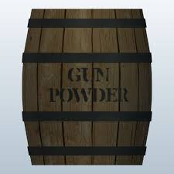  M | A
N | I
A

