FINAL SCORE:___________/50_________ Name:___________________

WWI Quiz

Directions: Answer all questions on the quiz. Please make sure that you answer each question completely. Remember to BE SPECIFIC! There is no penalty for guessing, so attempt each question.

PART 1: GROUPING
Choose the group that best fits each country’s participation in WWI.
(1 point each, 11 points for the section)

Allied Powers = A Central Powers = B Neutral = C

1. USA ______ 5. France______ 9. Serbia______

2. Austria-Hungary______ 6. Germany______ 10. Switzerland______

3. Russia______ 7. Great Britain______ 11. Turkey______

4. Italy (end of war) ______ 8. Spain______

PART 2: SHORT ANSWER
Answer each question in short response form (generally 4-6 sentences) on a separate piece of paper. Please write legibly. Spelling/grammar will not be part of your score. Make your answer as complete as possible. Attach the piece of paper to the back of the quiz when you’re finished.
(5 points each, 30 points for the section)

12. What is militarism? Describe what it is, and explain how it helped cause WWI.

13. What was the alliance system? Why was it problematic in Europe during WWI? Give at least one example!

14. Explain three differences between the Eastern and Western Fronts.

15. Describe why the Balkan Front was important during WWI.

16. How did Germany feel about the Treaty of Versailles? Why would they feel this way? Give two specific examples from the treaty to explain your answer.

17. Connect at least one of the causes of WWI to an event or character in AQotWF, and explain the connection you made.

A- BONUS CHALLENGE QUESTION: Make a connection between two of the causes of WWI. Describe how these causes were related. Think about how they may have reinforced or weakened each other! (5 points possible)

PART 3: FRONTS
On the map below, draw and label each of the main fronts of WWI. If it is a front that MOVED, please show that movement with arrows! (2 points each, 8 points total)

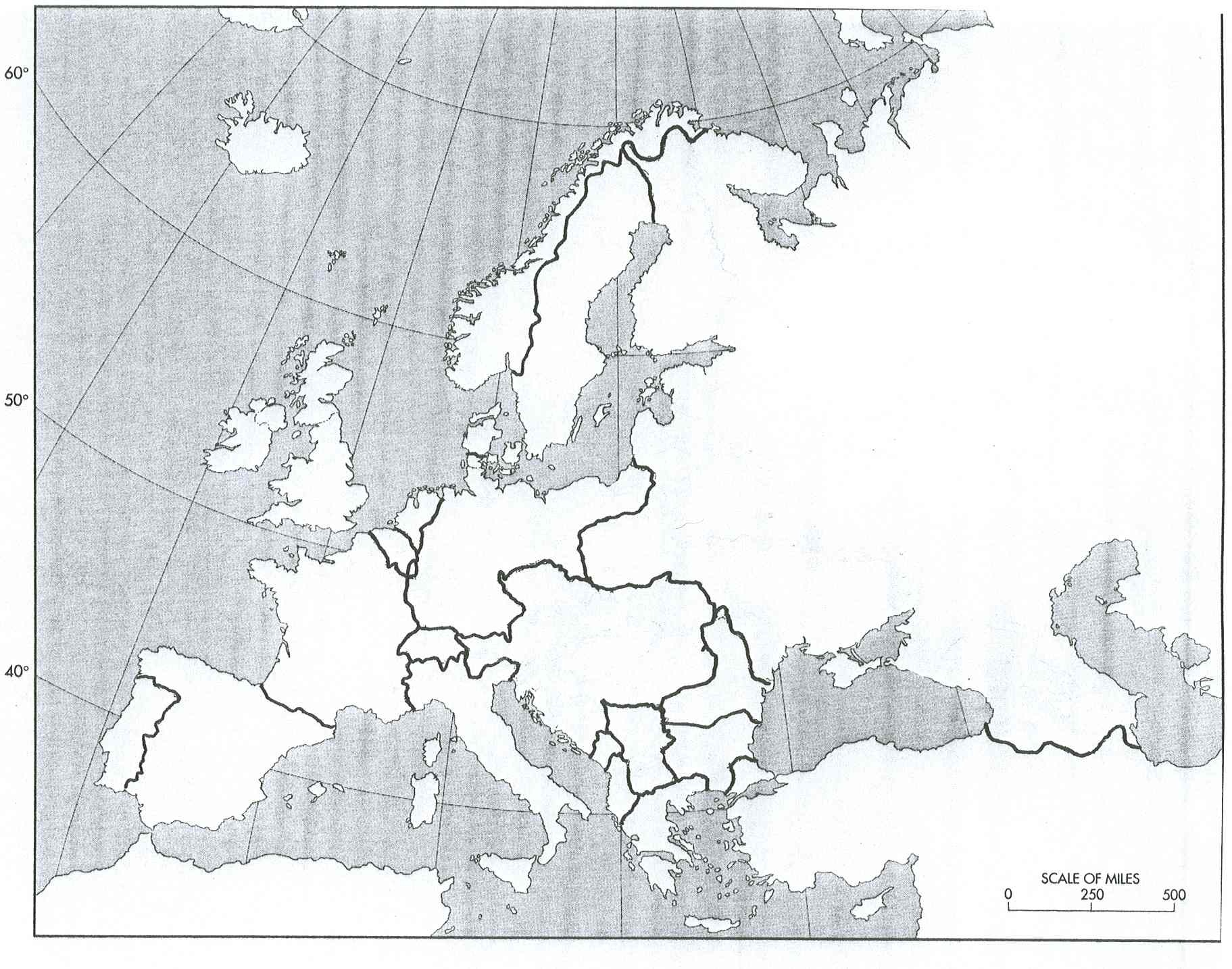

Extra Weirdo Point! Draw a cartoon that has Stephen interacting with a student in a funny way, OR, give him a recommendation of a song to look up. (1 point)

